UNIT 1:
Java Architecture
Java Architecture is a collection of components, i.e., JVM (Java Virtual Machine)-run java program, JRE(Java Runtime Environment)-provide environments to run java program , and JDK (Java Development Kit)-used to develop and run java program. It integrates the process of interpretation and compilation. It defines all the processes involved in creating a Java program. Java Architecture explains each and every step of how a program is compiled and executed.
JVM(Java virtual machine)- JVM runs Java programs.
- It executes bytecode (.class file).
- It converts bytecode into machine code.
- It makes Java platform independent.
Write once → Run anywhere (Windows, Linux, Mac).
JRE(Java Runtime Environment)- JRE provides the environment to run Java programs.
Which includes JVM, Java class libraries, Supporting files
JDK(Java Development Kit)- used to develop and run Java programs.
It includes JRE, Compiler (javac), Debugger and development tools

Java Architecture can be explained by using the following steps:
- There is a process of compilation and interpretation in Java.
- Java compiler converts the Java code into byte code.
- After that, the JVM converts the byte code into machine code.
- The machien code is then executed by the machine.
The following figure represents the Java Architecture in which each step is elaborate graphically.

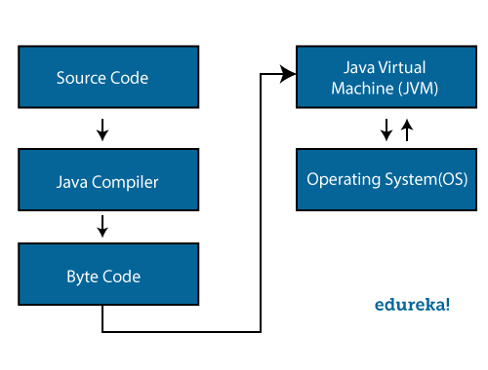

Components of Java Architecture
The Java architecture includes the three main components:
- Java Virtual Machine (JVM)
- .
- Java Development Kit (JDK)

Java Virtual Machine (JVM):
Java applications are called WORA(Write once Run Anywhere) because of their ability to run a code on any platform. This is done only because of JVM. JVM interprets the bytecode into machine code which is executed in the machine in which the Java program runs.
JVM performs the following functions:
- Loads the code
- Verifies the code
- Executes the code
- Provides runtime environment

Java Runtime Environment:
The Java Runtime Environment (JRE) is the essential software package that enables the execution of Java applications on a computer.

Java Development Kit:
The Java Development Kit (JDK) is a software package provided by Oracle (and other vendors) that includes tools and libraries necessary for developing, compiling, and running Java applications.
The Java “White Paper” Buzzwords(Features of Java)
The authors of Java wrote an influential white paper that explains their design goals and accomplishments. They also published a shorter overview that is organized along the following 11 buzzwords:
- Simple
- Object-Oriented
- Distributed
- Robust
- Secure
- Architecture-Neutral
- Portable
- Interpreted
- High-Performance
- Multithreaded
- Dynamic

Simple
Java is very easy to learn, and its syntax is simple, clean and easy to understand. According to Sun Microsystem, Java language is a simple programming language because:
- Java is an object-oriented programming language.
Everything in Java is an object. Object-oriented means we organize our software as a combination of different types of objects that incorporate both data and behavior.
Basic concepts of OOPs are:
- Object
- Class
- Inheritance
- Polymorphism
- Abstraction
- Encapsulation

Platform Independent
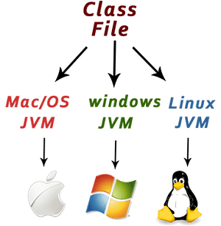
Java is platform independent because it is different from other languages like C, C++, etc. which are compiled into platform specific machines while Java is a write once, run anywhere language. A platform is the hardware or software environment in which a program runs.

Secured
Java is best known for its security. With Java, we can develop virus-free systems. Java is secured because:
- No explicit pointer
- Java programs run inside a virtual machine called a sandbox.
A sandbox is a safe and protected environment where Java programs are executed.
- Robust
Java is robust(Strong) because:
- There is a lack of pointers that avoids security problems.
- Java has strong memory management and exception handling to ensure reliable and error-free code.

Architecture-neutral

The architecture-neutral feature of Java means that Java programs can run on any computer system or device without needing modification.

Portable

Java programs can be easily moved from one system to another

.High-performance
Java is faster than other traditional interpreted programming languages because Java bytecode is "close" to native code. It is still a little bit slower than a compiled language (e.g., C++). Java is an interpreted language that is why it is slower than compiled languages, e.g., C, C++, etc.

Distributed
Java is distributed because it facilitates users to create distributed applications in Java. RMI (Java Remote Method Invocation) and EJB(enterprise java bean) (Middleware services such as security, transaction management etc) are used for creating distributed applications. This feature of Java makes us able to access files by calling the methods from any machine on the internet.

Multi-threaded
A thread is like a separate program, executing concurrently. We can write Java programs that deal with many tasks at once by defining multiple threads. The main advantage of multi-threading is that it doesn't occupy memory for each thread. It shares a common memory area. Threads are important for multi-media, Web applications, etc.

Dynamic
Java supports dynamic compilation and automatic memory management (garbage collection).

Installing Java in Visual Studio Code.
1. Go to https://code.visualstudio.com/docs/languages/java
2. Download Package
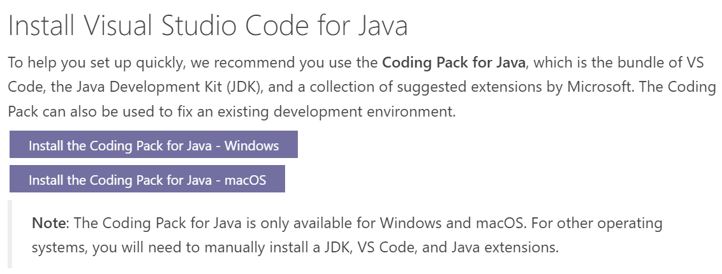
3. Open VS Code. Now open command ctrl+shift+p (in VS Code)
4. Select in dropdown (Java:create java project)
5. Select (No built tools)
6. Select your FolderLocation
7. Type name of your project given in screenshot
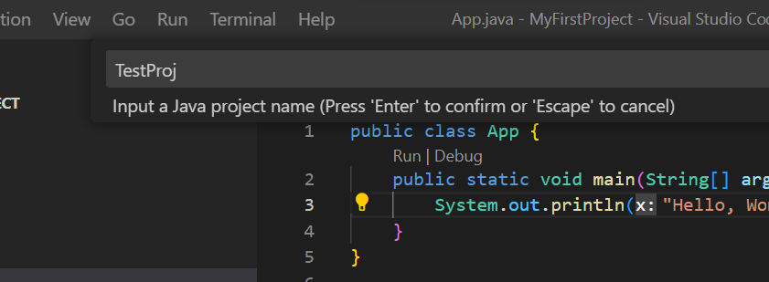
A Simple Java Program
The process of Java programming can be simplified in three steps:
- Create the program by typing it into a text editor and saving it to a file – HelloWorld.java.
- Compile it by typing “javac HelloWorld.java” in the terminal window.
- Execute (or run) it by typing “java HelloWorld” in the terminal window.
The below-given program is the most simple program of Java printing “Hello World” to the screen. Let us try to understand every bit of code step by step.
// This is a simple Java program.
// FileName : "HelloWorld.java".

class HelloWorld
{
public static void main(String args[])
{
System.out.println("Hello, World");
}
}

1. Class definition
This line uses the keyword class to declare that a new class is being defined.
class HelloWorld {
//
//Statements
}

2. HelloWorld
It is an identifier that is the name of the class. The entire class definition, including all of its members, will be between the opening curly brace “{” and the closing curly brace “}“.

3. main method:
In the Java programming language, every application must contain a main method. The main function(method) is the entry point of your Java application, and it’s mandatory in a Java program. whose signature in Java is:
public static void main(String[] args)
- public: So that JVM can execute the method from anywhere.
- static: The main method is to be called without an object. The modifiers public and static can be written in either order.
- void: The main method doesn’t return anything.
- main(): Name configured in the JVM. The main method must be inside the class definition. The compiler executes the codes starting always from the main function.
- String[]: The main method accepts a single argument, i.e., an array of elements of type String.
Like in C/C++, the main method is the entry point for your application and will subsequently invoke all the other methods required by your program.
The next line of code is shown here. Notice that it occurs inside the main() method.
System.out.println("Hello, World");
This line outputs the string “Hello, World” followed by a new line on the screen. Output is accomplished by the built-in println( ) method. The System is a predefined class that provides access to the system, and out is the variable of type output stream connected to the console.

Compiling and Running Java Programs.
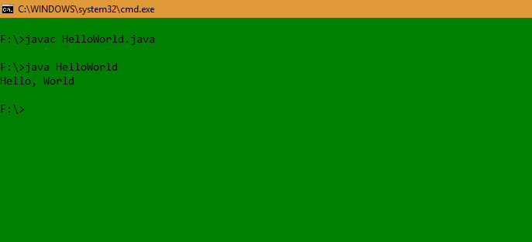

How to install JDK
Step 1: Java8 JDK is available https://www.oracle.com/java/technologies/downloads/#java8-windows
Step 2: Click To Download X64 Installer for windows
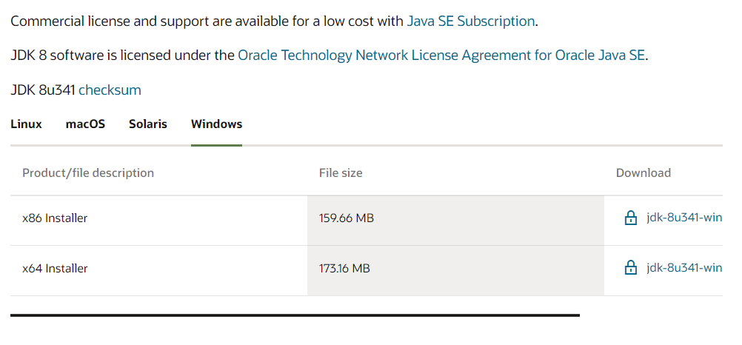
Step 3: After download, run the .exe file and follow the instructions to install Java on your machine. Once you install Java on your machine, you have to set up the environment variable.

Step 4: Go to Control Panel -> System and Security -> System. Under the Advanced System Setting option click on Environment Variables as highlighted below.

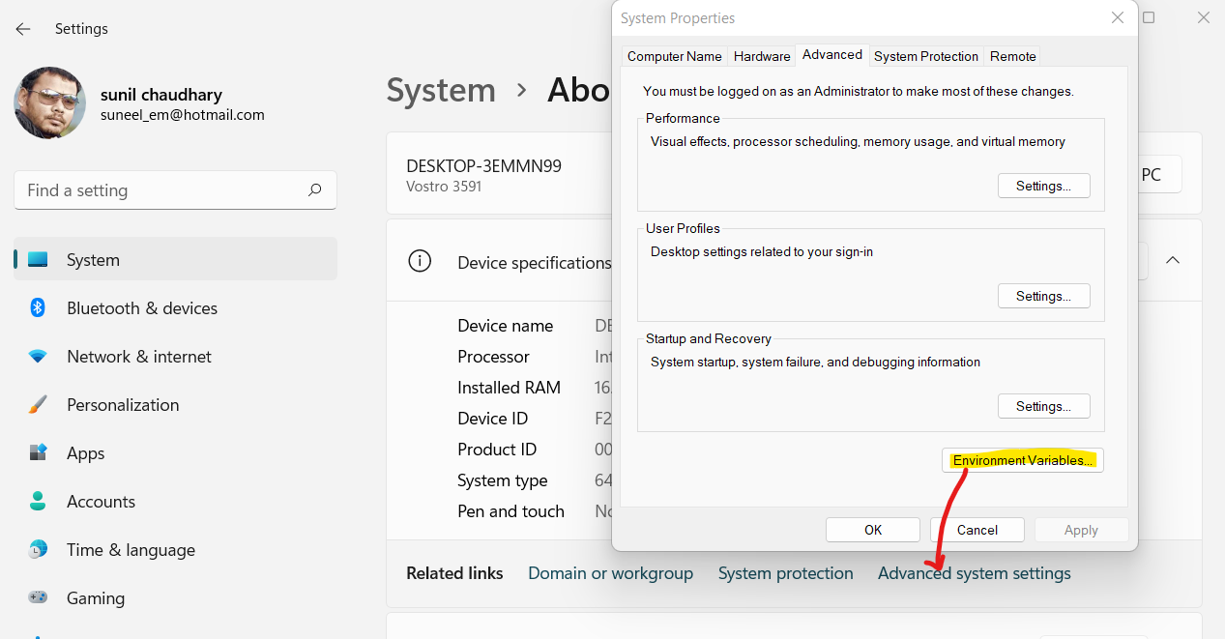
Step 5: Now, you have to alter the “Path” variable under System variables so that it also contains the path to the Java environment. Select the “Path” variable and click on the Edit button as highlighted below.
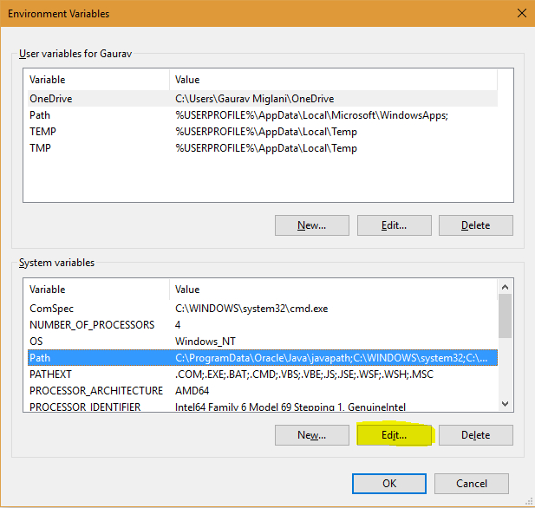

Step 6: You will see a list of different paths, click on the New button, and then add the path where java is installed. By default, java is installed in “C:\Program Files\Java\jdk\bin” folder OR “C:\Program Files(x86)\Java\jdk\bin”. In case, you have installed java at any other location, then add that path.
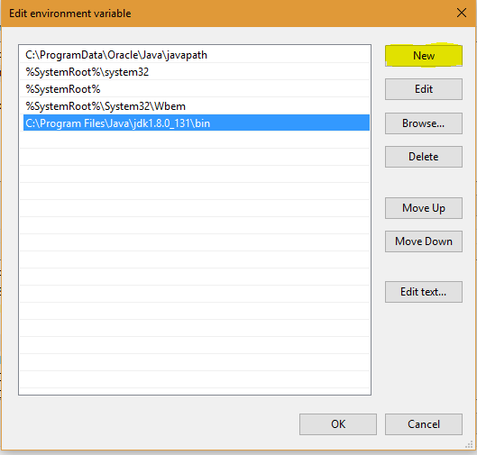
Step 6: Click on OK, Save the settings, and you are done !! Now to check whether the installation is done correctly, open the command prompt and type javac -version. You will see that java is running on your machine.

Conditional Statement
Java supports the usual logical conditions from mathematics:
- Less than: a < b
- Less than or equal to: a <= b
- Greater than: a > b
- Greater than or equal to: a >= b
- Equal to a == b
- Not Equal to: a != b
You can use these conditions to perform different actions for different decisions.
Java has the following conditional statements:
- Use if to specify a block of code to be executed, if a specified condition is true
- Use else to specify a block of code to be executed, if the same condition is false
- Use else if to specify a new condition to test, if the first condition is false
- Use switch to specify many alternative blocks of code to be executed

The if Statement
Use the if statement to specify a block of Java code to be executed if a condition is true.
Syntax:
if (condition) {
// block of code to be executed if the condition is true
}
Example:
if (20 > 18) {
System.out.println("20 is greater than 18");
}

The else Statement
Use the else statement to specify a block of code to be executed if the condition is false.
Syntax:
if (condition) {
// block of code to be executed if the condition is true
} else {
// block of code to be executed if the condition is false
}
Example:
int time = 20;
if (time < 18) {
System.out.println("Good day.");
} else {
System.out.println("Good evening.");
}
// Outputs "Good evening

The else if Statement
Use the else if statement to specify a new condition if the first condition is false.
Syntax:
if (condition1) {
// block of code to be executed if condition1 is true
} else if (condition2) {
// block of code to be executed if the condition1 is false and condition2 is true
} else {
// block of code to be executed if the condition1 is false and condition2 is false
}
Example:
int time = 22;
if (time < 10) {
System.out.println("Good morning.");
} else if (time < 20) {
System.out.println("Good day.");
} else {
System.out.println("Good evening.");
}
// Outputs "Good evening."

Switch Statement in Java

The switch statement is a multi-way branch statement. In simple words, the Java switch statement executes one statement from multiple conditions. It is like an if-else-if ladder statement. It provides an easy way to dispatch execution to different parts of code based on the value of the expression.

Syntax:

switch(expression) {
case x:
// code block
break;
case y:
// code block
break;
default:
// code block
}

Example:

int day = 4;

switch (day) {

case 1:
System.out.println("Monday");
break;
case 2:
System.out.println("Tuesday");
break;
case 3:
System.out.println("Wednesday");
break;
case 4:
System.out.println("Thursday");
break;
case 5:
System.out.println("Friday");
break;
case 6:
System.out.println("Saturday");
break;
case 7:
System.out.println("Sunday");
break;

}

// Outputs "Thursday" (day 4)

Loops in Java
- Simple for Loop
- For-each or Enhanced for Loop
A simple for loop is the same as C/C++. We can initialize the variable check condition and increment/decrement value. It consists of four parts:
- Initialization: It is the initial condition which is executed once when the loop starts. Here, we can initialize the variable, or we can use an already initialized variable. It is an optional condition.
- Condition: It is the second condition which is executed each time to test the condition of the loop. It continues execution until the condition is false. It must return boolean value either true or false. It is an optional condition.
- Increment/Decrement: It increments or decrements the variable value. It is an optional condition.
- Statement: The statement of the loop is executed each time until the second condition is false.
Syntax:
for(initialization; condition; increment/decrement)
{
//statement or code to be executed
}
Example:
//Code of Java for loop
for(int i=1;i<=10;i++){
System.out.println(i);
}

Example Print Pyramid
for(int i=1;i<=5;i++){
for(int j=1;j<=i;j++){
System.out.print("* ");
}
System.out.println();//new line
Example Print Pyramid
int term=6;
for(int i=1;i<=term;i++){
for(int j=term;j>=i;j--){
System.out.print("* "); }
System.out.println();//new line

Java for-each Loop
The for-each loop is used to traverse array or collection in Java. It is easier to use than simple for loop because we don't need to increment value and use subscript notation.
It works on the basis of elements and not the index. It returns element one by one in the defined variable.
Syntax:
for(data_type variable : array_name){
//code to be executed
}
Example:
//Declaring an array
int arr[]={12,23,44,56,78};
//Printing array using for-each loop
for(int i:arr){
System.out.println(i);
}

Array
in array is a collection of similar type of elements which has contiguous memory location.Array in Java is index-based, the first element of the array is stored at the 0th index, 2nd element is stored on 1st index and so on.
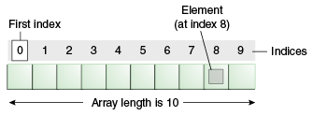

Advantages
- Code Optimization: It makes the code optimized, we can retrieve or sort the data efficiently.
- Random access: We can get any data located at an index position.

Disadvantages
- Size Limit: We can store only the fixed size of elements in the array. It doesn't grow its size at runtime. To solve this problem, collection framework is used in Java which grows automatically.

Types of Array in java
There are three types of array.
- Single Dimensional Array
- Multidimensional Array
- Jagged Array
Syntax:
dataType[] arr;
Instantiation of an Array
arr=new datatype[size];
Example:
public class App {
public static void main(String[] args) throws Exception {
int[] a=new int[5];//declaration and instantiation
a[0]=10;//initialization
a[1]=20;
a[2]=70;
a[3]=40;
a[4]=50;

int[] b=new int[]{1,2,3,4,5,6,7};//declaration and instantiation

//traversing array
for(int i=0;i<a.length;i++)//length is the property of array
System.out.println(a[i]);
}
}

Declaration, Instantiation and Initialization of Java Array
public class App {
public static void main(String[] args) throws Exception {
int a[]={33,3,4,5};//declaration, instantiation and initialization
//printing array
for(int i=0;i<a.length;i++)//length is the property of array
System.out.println(a[i]);

}
}

For-each Loop for Java Array
public class App {
public static void main(String[] args) throws Exception {
int arr[]={33,3,4,5};
//printing array using for-each loop
for(int i:arr)
System.out.println(i);

}
}

Multidimensional Array in Java
In such case, data is stored in row and column based index (also known as matrix form).
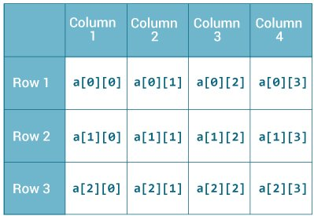

Syntax:
dataType[][] arrayRefVar;
Instantiate Multidimensional Array
int[][] arr=new int[2][2]{{1,2},{4,5}};//2 row and 2 column
int[,] arr=new int[2,2]{{1,2},{4,5}};

Example of Multidimensional Java Array
public class App {
public static void main(String[] args) throws Exception {
//declaring and initializing 2D array
int arr[][]={{1,2,3},{2,4,5},{4,4,5}};
//printing 2D array
for(int i=0;i<3;i++)
{
for(int j=0;j<3;j++)
{
System.out.print(arr[i][j]+" ");
}
System.out.println();
}
}
}

Jagged Array in Java
If we are creating odd number of columns in a 2D array, it is known as a jagged array. In other words, it is an array of arrays with different number of columns.
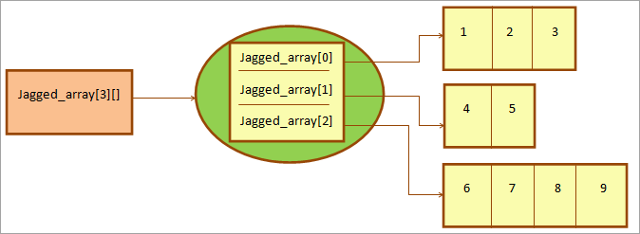

public class App {
public static void main(String[] args) throws Exception {
int[][] matrix = new int[][]{{ 1, 2, 3 },{ 4, 5, 6, 7 },{ 8, 9 }};
for (int i = 0; i < matrix.length; i++) //row
{
for (int j = 0; j < matrix[i].length; j++) //column
{
System.out.print(matrix[i][j]+" ");
}
System.out.println();
}
}
}
Output:
1 2 3
4 5 6 7
8 9

Lab: Write a Java program to initialize and display jagged array elements with sum of each row.

public class App {
public static void main(String[] args) throws Exception {

int[][] matrix = new int[][]{{1, 2, 3}, {4, 5, 6, 7}, {8, 9}};

for (int i = 0; i < matrix.length; i++) //row
{
int sum = 0;
for (int j = 0; j < matrix[i].length; j++) //column
{
System.out.print(matrix[i][j] + " ");
sum += matrix[i][j];
}
System.out.println("Sum of row " + (i + 1) + ": " + sum);
}
}
}

Lab: Write a Java program to initialize and display 2D array elements with sum of each row.
public class App {
public static void main(String[] args) throws Exception {

int[][] matrix = new int[][]{{1, 2, 3}, {4, 5, 6, 7}, {8, 9}};

for (int i = 0; i < matrix.length; i++) // row
{
int sum = 0; // Variable to store sum of elements in each row
for (int j = 0; j < matrix[i].length; j++) // column
{
System.out.print(matrix[i][j] + " ");
sum += matrix[i][j]; // Add the current element to the sum
}
System.out.println("Sum of row " + (i + 1) + ": " + sum); // Print sum of the current row
}
}
}

Lab:Write a Java program to initialize and display jagged array elements with sum of each column.
Lab: Write a Java program to find the maximum element in each row of a 2D array.
Lab:Write a Java program to count even and odd numbers in a jagged array.
Lab:Write a Java program to transpose a 2D array.

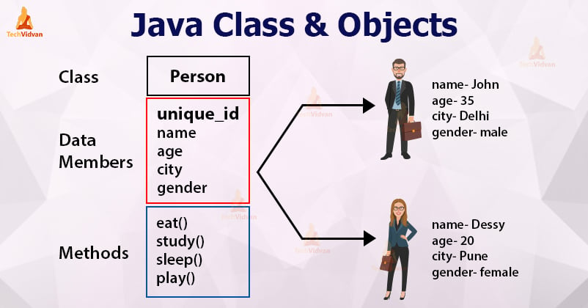
Class and Object
The object is an entity which has state and behavior. The object is an instance of a class.
An object has three characteristics:
- State: represents the data (value) of an object.
- Behavior: represents the behavior (functionality) of an object such as deposit, withdraw, etc.
- Identity: An object identity is typically implemented via a unique ID. The value of the ID is not visible to the external user. However, it is used internally by the JVM to identify each object uniquely.
A class is a group of objects which have common properties. It is a template or blueprint from which objects are created. A class in Java can contain:
- Fields
- Methods
- Constructors
- Blocks
- Nested class and interface

Syntax to declare a class:
class <class_name>{
field;
method;
}
Class and Object Example:
public class App {
public static void main(String[] args) throws Exception {
//Creating an object or instance
Student s1=new Student();//creating an object of Student
//Printing values of the object
System.out.println(s1.id);//accessing member through reference variable
System.out.println(s1.name);
}
}
//Defining a Student class.
class Student{
//defining fields
int id=1;//field or data member or instance variable
String name="Sunil Chaudhary";
//creating main method inside the Student class
}

Method Overloading
If a class has multiple methods having same name but different in parameters, it is known as Method Overloading.
If we have to perform only one operation, having same name of the methods increases the readability of the program.
public class App {
public static void main(String[] args) throws Exception {
DisplayOverloading obj = new DisplayOverloading();
System.out.println(obj.add(10, 20));
System.out.println(obj.add(10, 20, 30));
}
}
class DisplayOverloading
{
int add(int a, int b)
{
int sum = a+b;
return sum;
}
int add(int a, int b, int c)
{
int sum = a+b+c;
return sum;
}
}

Constructor Overloading
If a class has multiple constructors having same name but different in parameters, it is known as Constructor Overloading.
Example:
public class App {
public static void main(String[] args) throws Exception {
DisplayOverloading obj = new DisplayOverloading(2,3);
System.out.println(obj.Add());
}
}
class DisplayOverloading
{
int a=0;
int b=0;
public DisplayOverloading()
{

}
public DisplayOverloading(int aa, int bb)
{
a=aa;
b=bb;
}
public int Add()
{
return a+b;
}

}

Constructor Chaining
Constructor chaining is the process of calling one constructor from another constructor with respect to current object.
One of the main use of constructor chaining is to avoid duplicate codes while having multiple constructor (by means of constructor overloading) and make code more readable.
Constructor chaining can be done in two ways:
- By using this() keyword: It is used when we want to call the current class constructor within the same class.
- By using super() keyword: It is used when we want to call the superclass constructor from the base class.
Why do we need constructor chaining?
This process is used when we want to perform multiple tasks in a single constructor rather than creating a code for each task in a single constructor we create a separate constructor for each task and make their chain which makes the program more readable.
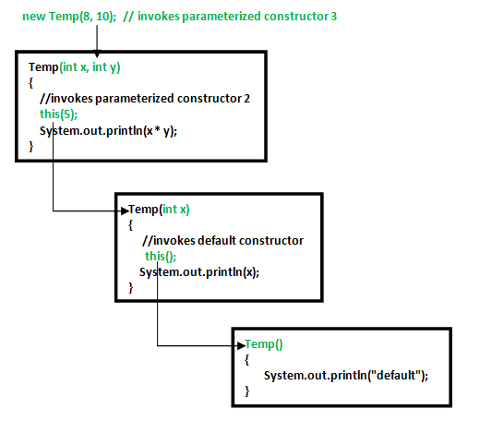

Example:
public class App
{
public static void main(String[] args)
{

ConstructorChain obj=new ConstructorChain();
}

}
class ConstructorChain
{
//default constructor
ConstructorChain()
{
this(“Samriddhi");
System.out.println("Default constructor called.");
}
//parameterized constructor
ConstructorChain(String str)
{
System.out.println("Parameterized constructor called");
}
}

Output:
Parameterized constructor called
Default constructor called.

Invoking Base class Constructor:
A derived class can call a constructor in its base class using the super keyword.

Example: using Super() keyword
public class App {
public static void main(String[] args) throws Exception {
ChildClass cls=new ChildClass();
}
}
class BaseClass
{
BaseClass()
{
System.out.println("Base Class Constructor is Called");
}
}
class ChildClass extends BaseClass
{
ChildClass()
{
super();
System.out.println("From Base Class Constructor");
}
}
Output:
Base Class Constructor is Called
From Base Class Constructor

Private Constructor(VVI)
The use of private constructor is to serve singleton classes.
A singleton class is one which limits the number of objects creation to one. Using private constructor, we can ensure that no more than one object can be created at a time.
It is often used in scenarios like managing database connections, logging, configuration settings, etc.
The main purpose of using a private constructor is to restrict object creation. Shown below example:
public class App {
public static void main(String[] args) throws Exception {
int square=Rectangle.Square(2);
}
}
class Rectangle {
private Rectangle() {

}
public static int Square(int x) {
return x * x;
}
}
Here,
You can't create: new Rectangle();
Only use: Rectangle.Square(2);

We will see in the below example how to use private constructor for limiting the number of objects for a singleton class.
Example2
public class App {
public static void main(String[] args) throws Exception {
// Step 4: Use getInstance() to access the single instance of Object Creation
SingleTonClass cls = SingleTonClass.objectCreationMethod();
// Step 5: Trying to create another instance (will return the same instance)
SingleTonClass cls1 = SingleTonClass.objectCreationMethod();
cls.display();
// Verify both references point to the same instance
System.out.println(cls == cls1);
}
}

class SingleTonClass {
// Step 1: Declare a private static instance of the class
private static SingleTonClass obj = null;
// Step 2: Private constructor prevents instantiation from other classes
private SingleTonClass() {

}
// Step 3: Public method to get the single instance of the class
public static SingleTonClass objectCreationMethod() {
if (obj == null) {
obj = new SingleTonClass();
}
return obj;
}
public void display() {
System.out.println("Singleton class Example");
}

}

Use of Private Constructor:
Singleton Pattern: To ensure that a class has only one instance and provides a global point of access to that instance.
Utility Classes: To prevent the instantiation of utility classes that contain only static methods and constants.
Factory Methods: To control object creation and provide more flexible ways to create instances through factory methods.
Preventing Sub-classing: To prevent the creation of subclasses by making the constructor private in a class intended to be used.
Resource Management: In classes responsible for resource management (e.g., managing database connections), you might use a private constructor to ensure proper resource allocation.

Access Modifiers
Access modifiers specify the availability of a parent class.
In real-time coding, we cannot allow child classes to have access to all of the other classes.
The availability of a data member, method, or constructor can be described in four ways.
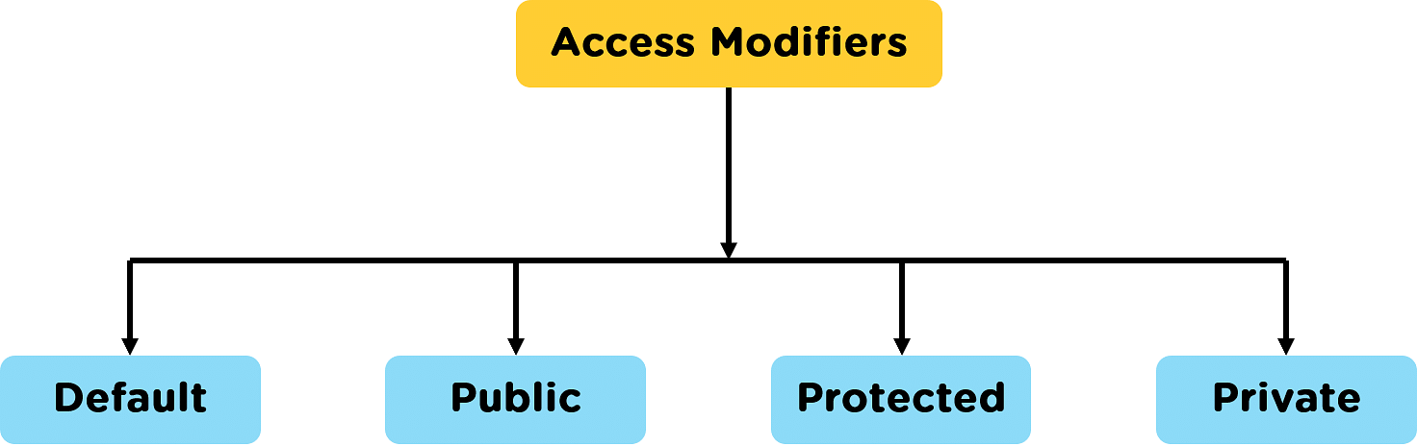

Modifier | Description
Default | declarations are visible only within the package (package private)
Private | declarations are visible within the class only(data member,Function Member)
Protected | declarations are visible within the package or all subclasses  (data member,Function Member)
Public | declarations are visible everywhere
Default Access Modifier:
Default modifier is also called (package-private access).
If no modifier is specified, java assigns default access
The Member (class, method and varriables) is access with in the same package
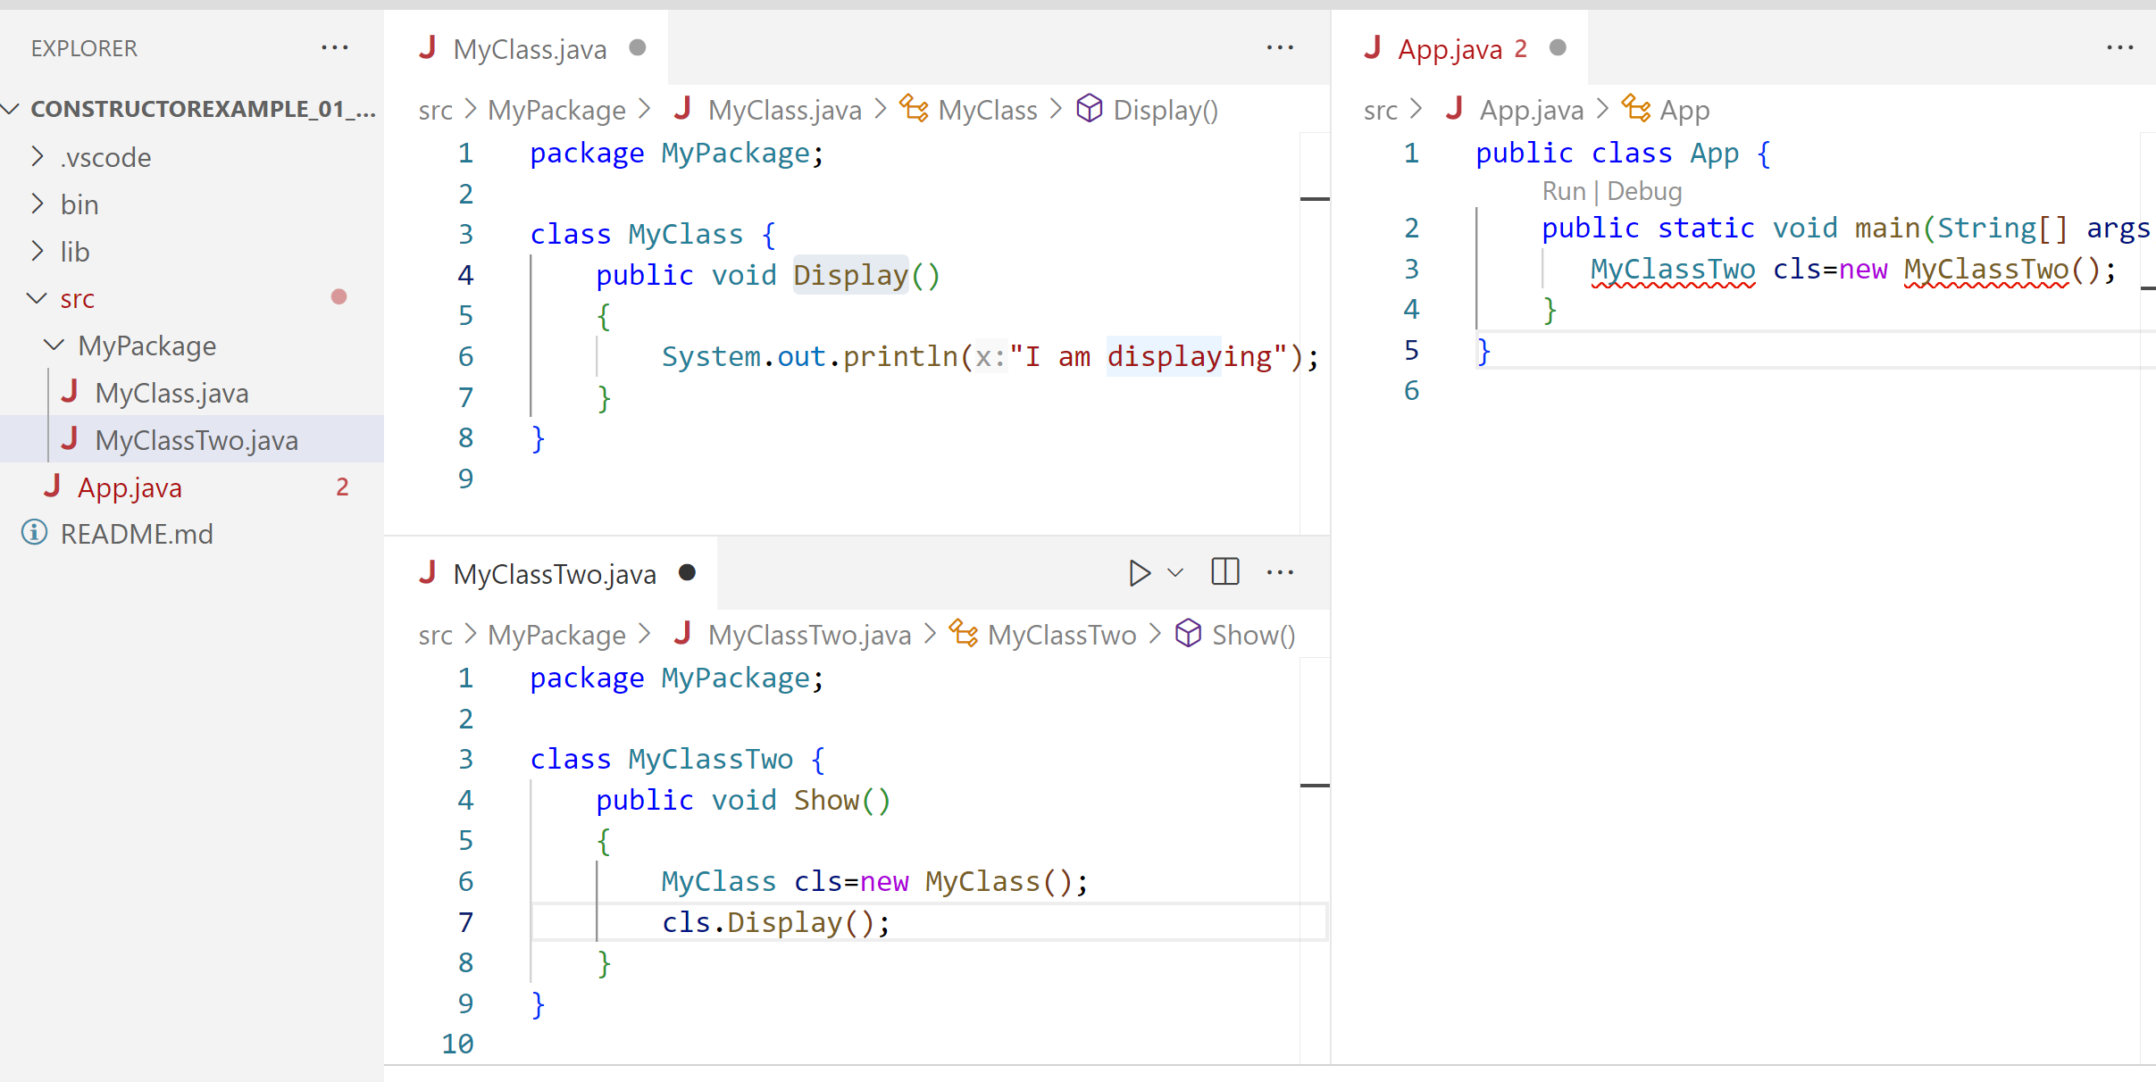
Here, the MyClassTwo and MyClass class has the default access modifier. And the class is visible to all the classes that belong to the MyPackage package. However, if we try to use the any(MyClassTwo or MyClass) class in another class outside of MyPackage, we will get a compilation error.
Private Access Modifier
When access modifier (method and varriables) declared private modifier it can access within the same class, they cannot be accessed outside of the class even if they are belong to same package.
For example,

public class App {
public static void main(String[] args) throws Exception {
MyClass cls=new MyClass();
cls.Show()
}
}
class MyClass
{
private int a=100;//private member
private void Display()//private function
{
System.out.println("Private value of a is: "+a);
}
public void Show()
{
Display();//allowed
System.out.println("Accessing Private value of a: "+a);
}
}

In the above example,
private member (a and Display) are accessible with in class shown in above code.
Even though it is declare with in the same package. It cannot access private member directly.
Private member access indirectly via public methods, in our code Show() is the public method create inside class.
we can also access private member using getter and setter we will see this example in encapsulation chapter for better understanding.

Protected Access Modifier
When methods and data members are declared protected, we can access them within the same package as well as from subclasses. For example,
class Animal {
protected int a;
// protected method
protected void display() {
System.out.println("I am an animal");
}
}
class Dog extends Animal {

public void Show()
{
display();
System.out.println(a);
}
}

Public Access Modifier
When methods, variables, classes, and so on are declared public, then we can access them from anywhere. The public access modifier has no scope restriction. For example,
// Animal.java file
// public class
public class Animal {
// public variable
public int legCount;

// public method
public void display() {
System.out.println("I am an animal.");
System.out.println("I have " + legCount + " legs.");
}
}

// Main.java
public class Main {
public static void main( String[] args ) {
// accessing the public class
Animal animal = new Animal();

// accessing the public variable
animal.legCount = 4;
// accessing the public method
animal.display();
}
}

Q.1 why we use interfaces when we have abstract classes?

Interface:
An interface in Java is a blueprint of a class.
- It is used to achieve total abstraction.
- Since java does not support multiple inheritances in the case of class, by using an interface it can achieve multiple inheritances.
- It is also used to achieve loose coupling.
- Interfaces are used to implement abstraction
Syntax:
interface <interface_name>{
// declare constant fields
// declare methods that abstract
// by default.
}

The relationship between classes and interfaces

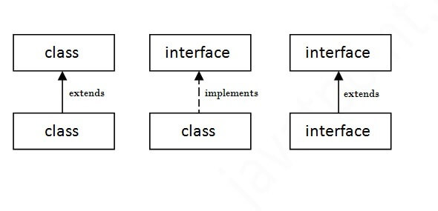

public class App
{
public static void main(String[] args) throws Exception {
A6 obj = new A6();
obj.print();
}
}
interface printable
{
void print();
}
class A6 implements printable
{
public void print()
{
System.out.println("Hello");
}
}

Difference Between Class and InterfaceThe major differences between a class and an interface are:
S. No. | Class | Interface
1. | In class, you can instantiate variables and create an object. | In an interface, you can’t instantiate variables and create an object.
2. | Class can contain concrete(with implementation) methods | The interface cannot contain concrete(with implementation) methods
3. | The access specifiers used with classes are private, protected, and public. | In Interface only one specifier is used- Public.

Q.Multiple inheritance is not supported through class in java, but it is possible by an interface, why?
Multiple inheritance is not supported in the case of class because of ambiguity. Multiple inheritance through classes can lead to issues like the "diamond problem," However, it is supported in case of an interface because there is no ambiguity. It is because its implementation is provided by the implementation class. For example:

public class App
{
public static void main(String[] args) throws Exception
{
A aa=new A();
aa.printA();
aa.printB();
}
}
interface IA
{
void printA();
}
interface IB
{
void printB();
}
class A implements IA,IB
{
public void printA()
{
System.out.println("MethodA");
}
public void printB()
{
System.out.println("MethodB");
}
}

Output:
MethodA
MethodB
Packages:
- A java package is a group of similar types of classes, interfaces and sub-packages.
- It helps in organizing and managing large code bases by grouping related classes together.
- A package name is the same as the directory(Folder) name which contains the .java files
Syntax:
package nameOfPackage;
There are two types of packages
- Pre-defined
- User Defined
Pre-Defined Packages examples are Java.lang, java.util, java,io, java.awt, java.swing, java.net, java.sql
User Defined Package example are package p1, package college, package mypackage
Advantages:
  - Java package is used to categorize the classes and interfaces so that they can be easily maintained.
  - Java package provides access protection.
  - Java package removes naming collision.
  - Reusability
  - Readability

How to access package from another package?
There are three ways to access the package from outside the package.
  - import package.*;

  - import package.classname;

  - fully qualified name.
import package.*;
package MyPackage;
public class MyClassOne {

}

import MyPackage.*;
public class App {
public static void main(String[] args) throws Exception {
MyClassOne cls=new MyClassOne();
}
}
import package.classname;
import MyPackage.MyClassOne;

public class App {
public static void main(String[] args) throws Exception {
MyClassOne cls=new MyClassOne();
}
}
fully qualified name.
public class App {
public static void main(String[] args) throws Exception {
MyPackage.MyClassOne cls=new MyPackage.MyClassOne();
}
}
Subpackage in java
Package inside the package is called the subpackage. It should be created to categorize the package further.
Example:
package MyPackage.MySubPackage;
public class MySubClassOne {

}

Advantage of Java Package
1) Java package is used to categorize the classes and interfaces so that they can be easily maintained.
2) Java package provides access protection.
3) Java package removes naming collision.
How to Create Java Packages
- Right click on Project select (New Package_
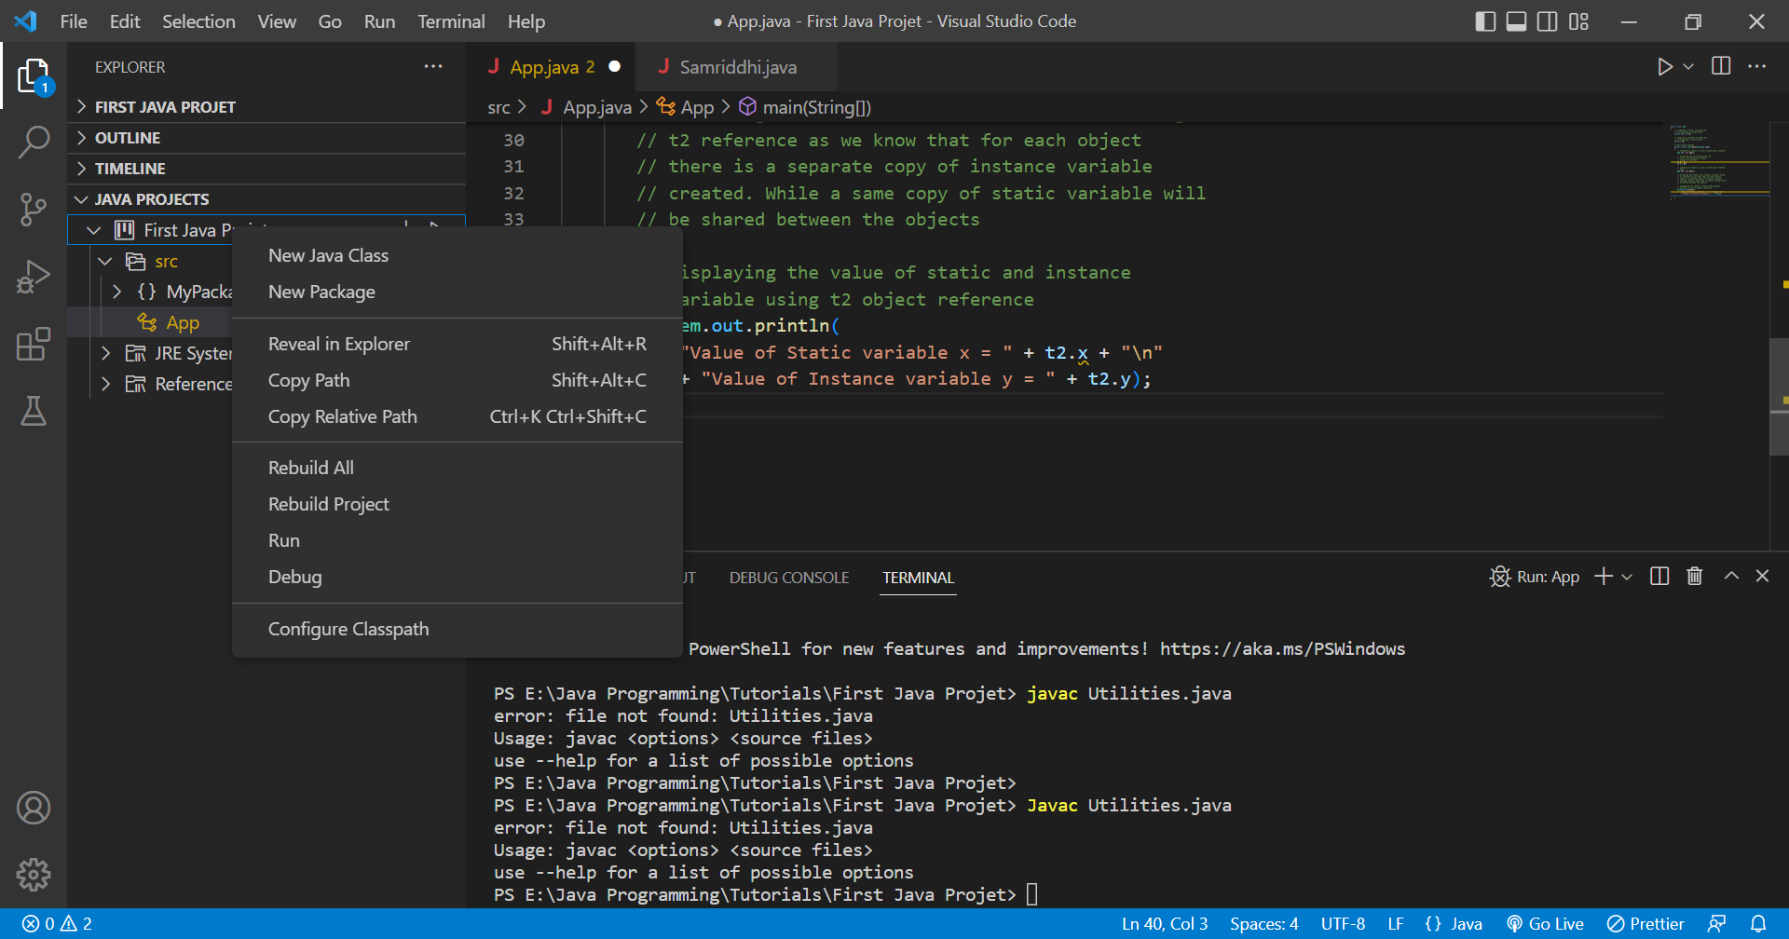

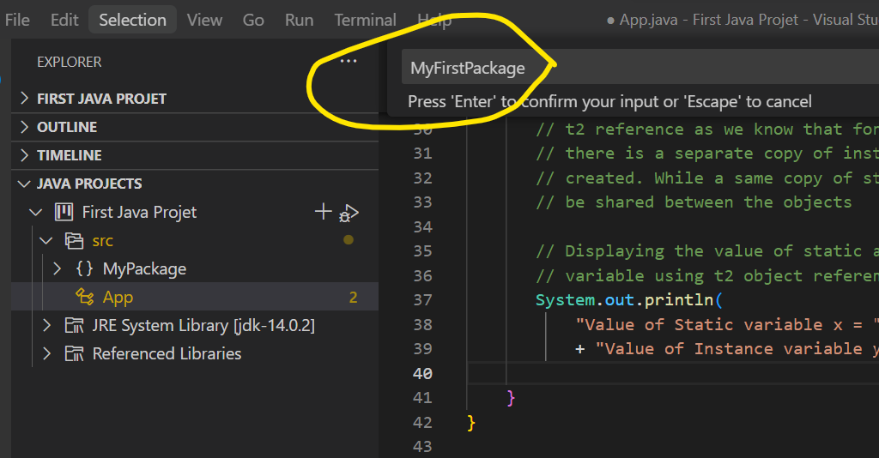
- Write Package Name

Package can be also created using command line
Simple example of java package
The package keyword is used to create a package in java.
package mypack;
public class Simple{
public static void main(String args[]){
System.out.println("Welcome to package");
}
}
How to compile java package
If you are not using any IDE, you need to follow the syntax given below:
javac -d directory javafilename
For example
javac -d .Simple.java
The -d switch specifies the destination where to put the generated class file. You can use any directory name like /home (in case of Linux), d:/abc (in case of windows) etc. If you want to keep the package within the same directory, you can use . (dot).
Inheritance:
Inheritance can be defined as the process where one class acquires the properties (methods and fields) of another. With the use of inheritance the information is made manageable in a hierarchical order.
The class which inherits the properties of other is known as subclass (derived class, child class) and the class whose properties are inherited is known as superclass (base class, parent class).
extends Keyword
extends is the keyword used to inherit the properties of a class. Following is the syntax of extends keyword.
Syntax:
class Super
{
.....
}
class Sub extends Super
{
.....
}
Example:
public class App
{

public static void main(String[] args)
{
DerivedClass cls=new DerivedClass();
cls.Method1();
cls.Method2();

}
}
class BaseClass {

public void Method1()
{
System.out.println("I am from base class");
}
}

class DerivedClass extends BaseClass {
public void Method2()
{
System.out.println("I am from child class");
}
}

Output:
I am from base class
I am from child class

The super keyword
- The super keyword is similar to this keyword. Following are the scenarios where the super keyword is used.
- It is used to differentiate the members of superclass from the members of subclass, if they have same names.
- It is used to invoke the superclass constructor from subclass.
Super class Example:
public class App
{

public static void main(String[] args)
{
DerivedClass cls=new DerivedClass();

cls.Method2();

}
}
class BaseClass {

public void Method1()
{
System.out.println("I am from base class");
}
}

class DerivedClass extends BaseClass {
public void Method2()
{
super.Method1();//calling base class method (similar to base keyword in C#)
System.out.println("I am from child class");
}
}

Types of Inheritance
There are various types of inheritance as demonstrated below.
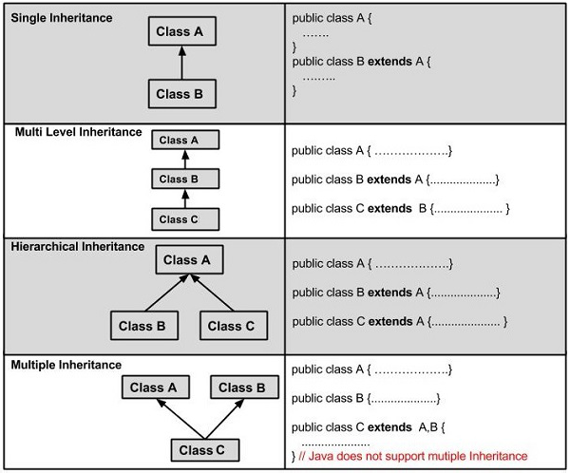
Single Inheritance:
When a class inherits another class, it is known as a single inheritance. In the example given below, A class inherits the B class, so there is the single inheritance.

public class App
{
public static void main(String[] args)
{
B cls=new B();
cls.Method2();
cls.Method1();
}
}
class A {
public void Method1()
{
System.out.println("I am from base class");
}
}
class B extends A {
public void Method2()
{
System.out.println("I am from child class");
}
}

Multilevel Inheritance Example
When there is a chain of inheritance, it is known as multilevel inheritance. As you can see in the example given below, C class inherits the B class which again inherits the A class, so there is a multilevel inheritance.

public class App
{
public static void main(String[] args)
{
C cls=new C();
cls.Method2();
cls.Method1();
cls.Method3();
}
}
class A {
public void Method1()
{
System.out.println("I am from A class");
}
}
class B extends A {
public void Method2()
{
System.out.println("I am from B class");
}
}
class C extends B {
public void Method3()
{
System.out.println("I am from C class");
}
}

Hierarchical Inheritance Example
When two or more classes inherits a single class, it is known as hierarchical inheritance. In the example given below, B and C classes inherits the A class, so there is hierarchical inheritance.

class A {
public void Method1()
{
System.out.println("I am from A class");
}
}
class B extends A {
public void Method2()
{
System.out.println("I am from B class");
}
}
class C extends A {
public void Method3()
{
System.out.println("I am from C class");
}
}

Why multiple inheritance is not supported in java?
To reduce the complexity and simplify the language, multiple inheritance is not supported in java.
Consider a scenario where A, B, and C are three classes. The C class inherits A and B classes. If A and B classes have the same method and you call it from child class object, there will be ambiguity to call the method of A or B class.
Since compile-time errors are better than runtime errors, Java renders compile-time error if you inherit 2 classes. So whether you have same method or different, there will be compile time error.
class A
{
void msg(){System.out.println("Hello");}
}
class B
{
void msg(){System.out.println("Welcome");}
}
class C extends A,B
{//suppose if it were
void msg(){System.out.println("Hi");}
}

How to Solve the Multiple Inheritance Problem in Java
Object Oriented Programming provides a user the feature of multiple inheritance, wherein a class can inherit the properties of more than a single parent class. In simpler terms, multiple inheritance means a class extending more than one class.
Multiple inheritance in java means one class implementing two or more than two interfaces simultaneously. In simple words multiple inheritance in java means one class accessing the states and behavior of two or more than two interfaces simultaneously.
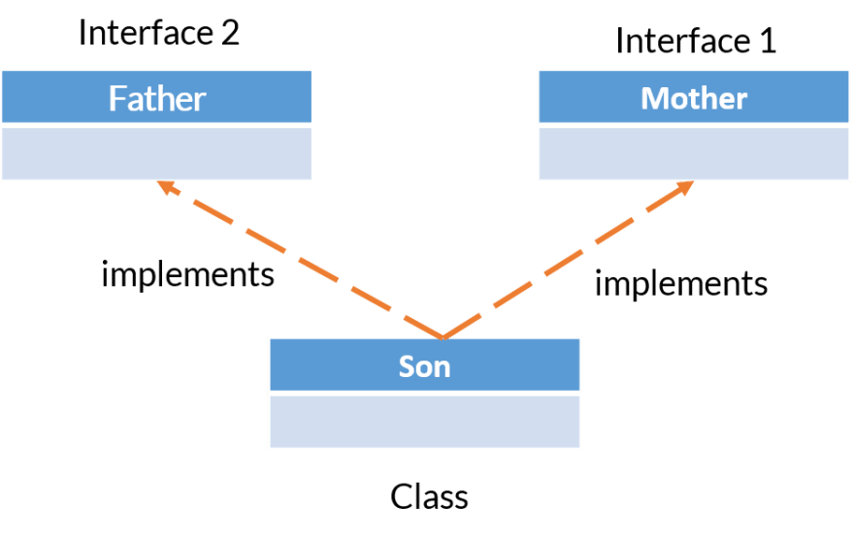
Example:

public class App
{
public static void main(String[] args)
{
C c=new C();
c.display();
c.show();
}
}
interface IA
{
public void show();
}
interface IB
{
public void display();
}
class C implements IA,IB
{
public void show()
{
System.out.println("Method One");
}
public void display()
{
System.out.println("Method One");
}
}

Overriding:

Method Overiding: Declaring a method in sub class which is already present in parent class is known as method overriding. Overriding is done so that a child class can give its own implementation to a method which is already provided by the parent class. In this case the method in parent class is called overridden method and the method in child class is called overriding method. In this guide, we will see what is method overriding in Java and why we use it.
public class App
{
public static void main(String[] args)
{
Boy obj = new Boy();
//This will call the child class version of eat()
obj.eat();
}
}
class Human{
//Overridden method
public void eat()
{
System.out.println("Human is eating");
}
}
class Boy extends Human{
//Overriding method
public void eat(){
System.out.println("Boy is eating");
}
}

Output:
Boy is eating
Overriding is also done in java using @override keyword
public class App
{
public static void main(String[] args)
{
Dog obj = new Dog();
obj.displayInfo();
}
}
class Animal {
public void displayInfo() {
System.out.println("I am an animal.");
}
}

class Dog extends Animal {
@Override
public void displayInfo() {
System.out.println("I am a dog.");
}
}
Output: I am a dog.
Advantage of method overriding:
The main advantage of method overriding is that the class can give its own specific implementation to a inherited method without even modifying the parent class code.
This is helpful when a class has several child classes, so if a child class needs to use the parent class method, it can use it and the other classes that want to have different implementation can use overriding feature to make changes without touching the parent class code.

Super keyword in Method Overriding:
The super keyword is used in method overriding to call the method of the superclass (parent class) from the subclass (child class). When you override a method in the subclass, you can still access the original method from the superclass using super. By using super we can call the overridden method as shown in the example below:
public class App
{
public static void main(String[] args)
{
ChildClass obj = new ChildClass();
obj.myMethod();
}
}
class ABC{
public void myMethod()
{
System.out.println("Overridden method");
}
}
class ChildClass extends ABC{
public void myMethod(){
//This will call the myMethod() of parent class
super.myMethod();
System.out.println("Overriding method");
}
}

Output:
Overridden method
Overriding method
Access Specifiers in Method Overriding:
The same method declared in the superclass and its subclasses can have different access specifiers. However, there is a restriction.
We can only use those access specifiers in subclasses that provide larger access than the access specifier of the superclass. For example,
Suppose, a method myClass() in the superclass is declared protected. Then, the same method myClass() in the subclass can be either public or protected, but not private.
public class App
{
public static void main(String[] args)
{
Dog d1 = new Dog();
d1.displayInfo();
}
}
class Animal {
protected void displayInfo() {
System.out.println("I am an animal.");
}
}

class Dog extends Animal {
public void displayInfo() {
System.out.println("I am a dog.");
}
}
Output:
I am a dog.
Java Overriding Rules:
- Both the superclass and the subclass must have the same method name, the same return type and the same parameter list.
- We cannot override the method declared as final and static.
- We should always override abstract methods of the superclass
Inner Class:
In Java, just like methods, variables of a class too can have another class as its member. Writing a class within another is allowed in Java. The class written within is called the nested class, and the class that holds the inner class is called the outer class.
There are certain advantages associated with inner classes are as follows:
- Making code clean and readable.
- Private methods of the outer class can be accessed, so bringing a new dimension and making it closer to the real world.
- Optimizing the code module.
Syntax:
class Java_Outer_class
{
//code
class Java_Inner_class
{
//code
}
}

Types of Inner Class
- Local Inner Classes
- Anonymous Inner Classes
- Static Inner Classes

Local Inner Class: declared class inside class
public class App
{
public static void main(String[] args) throws Exception
{
Outer.Inner in = new Outer().new Inner();
in.show();
}
}
class Outer {

class Inner {
// show() method of inner class
public void show()
{
// Print statement
System.out.println("In a nested class method");
}
}
}

Anonymous Inner Class: An Anonymous Inner Class in Java is a way to create a class on the spot, without giving it a name. It's often used when you need to quickly implement a method or override methods of an interface or superclass.
Java Anonymous inner class can be created in two ways:
- Class (may be abstract or concrete).
- Interface

//class 2
public class App
{
// An anonymous class with Demo as base class
static Demo d = new Demo()
{
// Method 1
// show() method
void show()
{
// Calling method show() via super keyword
// which refers to parent class
super.show();
// Print statement
System.out.println("i am in Flavor1Demo class");
}
};
public static void main(String[] args) throws Exception
{
d.show();
}
}
// Class 1
class Demo {
void show()
{
System.out.println("i am in show method of super class");
}
}

Example Using Abstract Class
abstract class Utilities{
abstract void display();
}
public class App {
public static void main(String[] args)
{
Utilities p=new Utilities()
{
void display()
{
System.out.println("Good Morning");
}
};
p.display();
}
}

Example Using Interface
interface Utilities{
public void display();
}
public class App {
public static void main(String[] args)
{
Utilities p=new Utilities()
{
public void display()
{
System.out.println("Good Morning");
}
};
p.display();
}
}
Static Inner Class: Static nested classes are not technically inner classes. They are like a static member of outer class.
//class 3 Main CLass
public class App
{

public static void main(String[] args) throws Exception
{
Outer.Inner obj = new Outer.Inner();
obj.display();
}
}
class Outer {
private static void outerMethod()
{
System.out.println("inside outerMethod");
}
static class Inner {
public static void display()
{
System.out.println("inside inner class Method");
outerMethod();
}
}
}

Final and Static Modifier
Final Access Modifier is a modifier applicable to classes, methods, and variables. If we declare a parent class method as final then we can’t override that method in the child class because its implementation is final and if a class is declared as final we can’t extend the functionality of that class i.e we can’t create a child class for that class i.e inheritance is not possible for final classes.
Every method present inside the final class is always final by default but every variable present inside the final class need not be final.
The main advantage of the final keyword is we can achieve security and we can provide a unique implementation.
Preventing Inheritance
Immutable Variables
Preventing Method Overriding
But the main disadvantage of the final keyword is we are missing key benefits of OOPs like Inheritance(Because of the final class)

Example:
// Class 2
// Sub-class
// Extending above class
public class App extends P
{
// Method 1
// Trying to override the last name
public void surName()
{
// Display surname
System.out.println("Sharma");
}
// Method 2
// Main driver method

public static void main(String[] args)
{
// Display message
System.out.println("Samriddhi");
}
}
// Class 1
// Super-class
class P {
// Method 1
// To declare first name
public void firstName()
{
// Passing name and print it
System.out.println("SUnil");
}
// Method 2
// To declare last name
public final void surName()
{
// Passing name and print it
System.out.println("Chaudhary");
}
}
Throws an exception

Static Access Modifier
- The static modifier is used to create members (fields or methods) that belong to the class itself, rather than to a specific instance of the class.
- A static method can be called on the class itself, without needing an instance of the class.
- Static members can be accessed using the class name (e.g., ClassName.staticField or ClassName.staticMethod()).
Instance data members declaration should preceded by a keyword static.
Static variables reduce the amount of memory used by a program.
In Static, Memory is allocated only once, at the time of class loading.
Static variables Exists for the entire lifetime of the program.
- Static data member is like a global and is available to all methods.

public class App
{
/// Creating a static variable and
// initializing a custom value
static int x = 10;

// Creating a instance variable and
// initializing a custom value
int y = 20;

// Main driver method
public static void main(String[] args)
{
// Creating an object of class inside main() method
App t1 = new App();

// Accessing and re-initializing the
// static and instance variable
// using t1 reference
t1.x = 88;
t1.y = 99;

// Creating an object of class inside main() method
// again
App t2 = new App();

// Accessing the static and instance variable using
// t2 reference as we know that for each object
// there is a separate copy of instance variable
// created. While a same copy of static variable will
// be shared between the objects

// Displaying the value of static and instance
// variable using t2 object reference
System.out.println(
"Value of Static variable x = " + t2.x + "\n"
+ "Value of Instance variable y = " + t2.y);

}
}

Handling Exceptions:
Exception Handling in Java is one of the effective means to handle the runtime errors so that the regular flow of the application can be preserved. Java Exception Handling is a mechanism to handle runtime errors such as ClassNotFoundException, IOException, SQLException, RemoteException, etc.
Exception is an unwanted or unexpected event, which occurs during the execution of a program, i.e. at run time, that disrupts the normal flow of the program’s instructions. Exceptions can be caught and handled by the program. When an exception occurs within a method, it creates an object. This object is called the exception object. It contains information about the exception, such as the name and description of the exception and the state of the program when the exception occurred
Major reasons why an exception Occurs
- Invalid user input
- Device failure
- Loss of network connection
- Physical limitations (out of disk memory)
- Code errors
- Opening an unavailable file
Errors represent irrecoverable conditions such as Java virtual machine (JVM) running out of memory, memory leaks, stack overflow errors, library incompatibility, infinite recursion, etc. Errors are usually beyond the control of the programmer, and we should not try to handle errors.

Differences between Error and Exception:
Error: An Error indicates a serious problem that a reasonable application should not try to catch.
Exception: Exception indicates conditions that a reasonable application might try to catch.
S.No | Errors | Exceptions
1. | The error indicates trouble that primarily occurs due to the lack of system resources. | The exceptions are the issues that can appear at runtime and compile time.
2. | It is not possible to recover from an error. | It is possible to recover from an exception.
3. | In java, all the errors are unchecked.(runtime) | In java, the exceptions can be both checked and unchecked.(compile and runtime)
4. | The system in which the program is running is responsible for errors. | The code of the program is responsible for exceptions.
5. | They are described in the java.lang.Error package. | They are described in java.lang.Exception package

Handling exceptions in Java.
- try...catch block
- finally block
- throw and throws keyword
Java try...catch block
The try-catch block is used to handle exceptions in Java. Here's the syntax of try...catch block:
try {
// code
}
catch(Exception e) {
// code
}

- Here, we have placed the code that might generate an exception inside the try block. Every try block is followed by a catch block.
- When an exception occurs, it is caught by the catch block. The catch block cannot be used without the try block.
Example:
public class App
{
public static void main(String[] args)
{
try {

// code that generate exception
int divideByZero = 5 / 0;
System.out.println("Rest of code in try block");
}

catch (ArithmeticException e) {
System.out.println("ArithmeticException => " + e.getMessage());
}
}
}

Output:
ArithmeticException => / by zero
Java finally block
- In Java, the finally block is always executed no matter whether there is an exception or not.
- The finally block is optional. And, for each try block, there can be only one finally block.
The basic syntax of finally block is:
try {
//code
}
catch (ExceptionType1 e1) {
// catch block
}
finally {
// finally block always executes
}
If an exception occurs, the finally block is executed after the try...catch block. Otherwise, it is executed after the try block. For each try block, there can be only one finally block.
Example: Java Exception Handling using finally block

public class App
{
public static void main(String[] args)
{
try {
// code that generates exception
int divideByZero = 5 / 0;
}

catch (ArithmeticException e) {
System.out.println("ArithmeticException => " + e.getMessage());
}

finally {
System.out.println("This is the finally block");
}
}
}
Output:
ArithmeticException => / by zero
This is the finally block
In the above example, we are dividing a number by 0 inside the try block. Here, this code generates an ArithmeticException.
The exception is caught by the catch block. And, then the finally block is executed.
Java throw and throws keyword
The Java throw keyword is used to explicitly throw a single exception.
When we throw an exception, the flow of the program moves from the try block to the catch block.
public class App
{
public static void divideByZero() {

// throw an exception
throw new ArithmeticException("Trying to divide by 0");
}
public static void main(String[] args)
{
divideByZero();
}
}
In the above example, we are explicitly throwing the ArithmeticException using the throw keyword.
Similarly, the throws keyword is used to declare the type of exceptions that might occur within the method. It is used in the method declaration.
Java throws keyword:
import java.io.*;

public class App
{
// declareing the type of exception
public static void findFile() throws IOException
{

// code that may generate IOException
File newFile = new File("test.txt");
FileInputStream stream = new FileInputStream(newFile);
}

public static void main(String[] args)
{
try {
findFile();
}
catch (IOException e) {
throw e;
System.out.println(e);
}
}
}

Output:
java.io.FileNotFoundException: test.txt (The system cannot find the file specified)
When we run this program, if the file test.txt does not exist, FileInputStream throws a FileNotFoundException which extends the IOException class.
The findFile() method specifies that an IOException can be thrown. The main() method calls this method and handles the exception if it is thrown.
If a method does not handle exceptions, the type of exceptions that may occur within it must be specified in the throws clause.

How to Create Exception Class and What is custom exceptions or User defined Exception?
Java exceptions cover almost all the general type of exceptions that may occur in the programming. However, we sometimes need to create custom exceptions.
Following are few of the reasons to use custom exceptions:
- To catch and provide specific treatment to a subset of existing Java exceptions.
- Business logic exceptions: These are the exceptions related to business logic and workflow. It is useful for the application users or the developers to understand the exact problem.
In order to create custom exception, we need to extend Exception class that belongs to java.lang package.
Consider the following example, where we create a custom exception named WrongFileNameException:
public class App
{
public static void main(String[] args)
{
try {
// Throw an object of user defined exception
throw new MyException("User Defined");
}
catch (MyException ex) {
System.out.println("Caught");

// Print the message from MyException object
System.out.println(ex.getMessage());
}
}
}
class MyException extends Exception {
public MyException(String s)
{
// Call constructor of parent Exception
super(s);
}
}

Output:
Caught
User Defined

Concurrency:
Java Concurrency package covers concurrency, multithreading, and parallelism on the Java platform. Concurrency is the ability to run several or multi programs or applications in parallel. The backbone of Java concurrency is threads (a lightweight process, which has its own files and stacks and can access the shared data from other threads in the same process).
The throughput and the interactivity of the program can be improved by performing time-consuming tasks asynchronously or in parallel.
Java 5 added a new package to the java platform ⇾ java.util.concurrent package. This package has a set of classes and interfaces that helps in developing concurrent applications (multithreading) in java.
Concurrency Problem:
Because threads run at the same time as other parts of the program, there is no way to know in which order the code will run. When the threads and main program are reading and writing the same variables, the values are unpredictable. The problems that result from this are called concurrency problems.
Thread:
Thread allows a program to operate more efficiently by doing multiple things at the same time.
Threads can be used to perform complicated tasks in the background without interrupting the main program.
Life cycle of a Thread (Thread States)

A thread can be in one of the five states. The life cycle of the thread in java is controlled by JVM. The java thread states are as follows:
- New: Thread created, not yet started.
- Runnable: Started, ready for execution.
- Running: Currently executing its code.
- Non-Runnable (Blocked): Waiting for a condition to proceed.
- Terminated: Finished its execution, cannot be restarted.

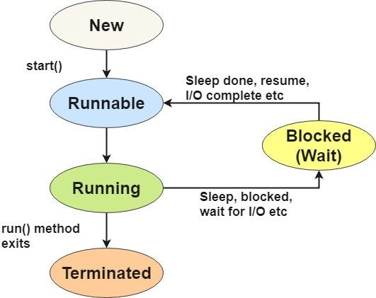

Creating Thread:
We can create a new thread by either extending the Thread class or implementing the Runnable interface.
Extending java.lang.Thread:
- Extending the Thread class:
public class App {
public static void main(String[] args) throws Exception {
MyThread thread = new MyThread();
thread.start(); // Start the thread
}
}
class MyThread extends Thread {
public void run() {
// Code to be executed in the thread
System.out.println("Thread is running.");
}
}
Or,
public class App {
public static void main(String[] args) throws Exception {
Thread t1=new Thread() {
public void run() {
// Code to be executed in the thread
System.out.println("Thread is running.");
}
};
t1.start();
}
}

Implementing java.lang.Runnable:
- Implementing the Runnable interface:

public class App {
public static void main(String[] args) throws Exception {
MyRunnable runnable = new MyRunnable();
Thread thread = new Thread(runnable);
thread.start(); // Start the thread
}
}
class MyRunnable implements Runnable {
public void run() {
// Code to be executed in the thread
System.out.println("Thread is running.");
}
}
Or,
public class App {
public static void main(String[] args) throws Exception {
Runnable r1=new Runnable() {
public void run() {
// Code to be executed in the thread
System.out.println("Thread is running.");
}
};
Thread t1=new Thread(r1);
t1.start();

}
}

How can you write multithreaded programs in java? Discuss with suitable example.
What is multithreading? Why is it important to develop in computer programs? Discuss life cycle of thread in detail.
Why multithreading is important in programming? Discuss
Why do we need to synchronize the thread? Justify with an example. An array with an odd number of elements is said to be centered if all elements (except the middle one) are strictly greater than the value of the middle element. Note that only arrays with an odd number of elements have a middle element. Write a function that accepts an integer array and returns 1 if it is a centered array, otherwise it returns 0.

Multithreading:
The process of executing multiple threads simultaneously is known as multithreading.
Multithreading could be defined as the programming language’s functionality to get the various tasks executed simultaneously. It is a common feature that facilitates simultaneous thread execution. The thread is nothing but a small task that is supposed to run concurrently.
What are the differences between process and thread?
Threads are not independent from each other unlike processes. As a result, threads shares with other threads their code section, data section and OS resources like open files and signals. But, like processes, a thread has its own program counter (PC), a register set, and a stack space.
Why Multithreading? Threads are popular way to improve application through parallelism. For example, in a browser, multiple tabs can be different threads. MS word uses multiple threads, one thread to format the text, other thread to process inputs, etc.
Threads operate faster than processes due to following reasons:
1) Thread creation is much faster.
2) Context switching between threads is much faster.
3) Threads can be terminated easily
4) Communication between threads is faster.

Multitasking vs Multithreading vs Multiprocessing vs parallel processing
If you are new to java, you may get confused among these terms as they are used quite frequently when we discuss multithreading. Let’s talk about them in brief.
Multitasking: Ability to execute more than one task at the same time is known as multitasking.
Multithreading: We already discussed about it. It is a process of executing multiple threads simultaneously. Multithreading is also known as Thread-based Multitasking.
Multiprocessing: It is same as multitasking, however in multiprocessing more than one CPUs are involved. On the other hand, one CPU is involved in multitasking.
Parallel Processing: It refers to the utilization of multiple CPUs in a single computer system.

Working with Multithreading:
It is implemented using the run function. The run function can be defined as the special function that starts the thread execution. This function could be invoked using the start function that has to be used with the object to bring the thread into execution. Once the thread starts, it will perform all the tasks defined underrun(). Based on the priority, the thread is used to choose which one has to run and which one has to wait. we will use the run() and start() functions to bring the thread’s multiple executions.
Advantages of Multithreading in java
When we talk about the quick execution of any program, it just has to perform several operations simultaneously. It is advantageous when making an efficient program that executes quickly at almost no time.
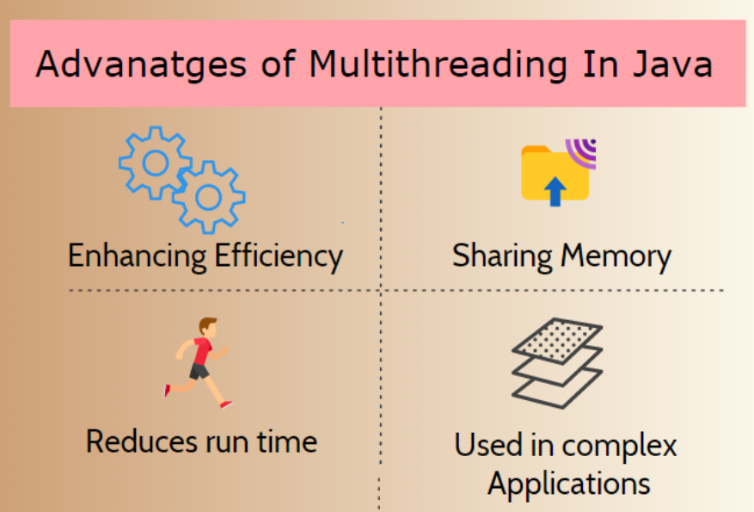

Enhancing efficiency – It makes the application very efficient by making the optimal use of the CPUs. I let the threads use the CPU efficiently by making use of it while other threads wait for some output.
Sharing Memory – The best part about multithreading is that the thread it uses does not occupy the memory but uses it on a shared basis. Hence, it also makes efficient use of memory by sharing it appropriately.
​Reduces run time – It usually mitigates the time utilized by an application to run the particular program. The time saved by threads could be used for other programs to minimize program execution time.
Used in complex applications – Threads in application development make it easy to create the modules in the application. They are being used very efficiently to make designing and development easy.
Implementing Multithreading by extending Thread
The above example starts creating threads 8 times as mentioned there and ensures that the number assigned with the threads should start from 8. The output for this program will be below.
Example:
public class App
{

public static void main(String[] args)
{

for(int i=0; i<8; i++)
{
TestMultithreading obj=new TestMultithreading();
obj.start();
}
}

}
class TestMultithreading extends Thread
{
public void run()
{
try{
System.out.println("I am thread number"+ Thread.currentThread().getId());

}
catch(Exception ex)
{
System.out.println("Go to Exception");
}
}
}

Output:
I am thread number14
I am thread number15
I am thread number21
I am thread number20
I am thread number16
I am thread number18
I am thread number17
I am thread number19

Implementing Multithreading by Runnable interface:
Example:
public class App
{

public static void main(String[] args)
{

for(int i=0; i<8; i++)
{
Thread obj=new Thread(new TestMultithreading());
obj.start();

}
}

}
class TestMultithreading implements Runnable
{
public void run()
{
try{
System.out.println("I am thread number"+ Thread.currentThread().getId());

}
catch(Exception ex)
{
System.out.println("Go to Exception");
}
}
}

Output:
I am thread number18
I am thread number20
I am thread number21
I am thread number15
I am thread number16
I am thread number19
I am thread number17
I am thread number14
Priority of a Thread (Thread Priority):
Each thread have a priority. Priorities are represented by a number between 1 and 10. 3 constants defined in Thread class:
- public static int MIN_PRIORITY
- public static int NORM_PRIORITY
- public static int MAX_PRIORITY
Default priority of a thread is 5 (NORM_PRIORITY). The value of MIN_PRIORITY is 1 and the value of MAX_PRIORITY is 10.
Example:

Lab: Write a simple java program to demonstrate how thread Priority handled.
public class App {
public static void main(String[] args) throws Exception {
TestMultiPriority1 m1=new TestMultiPriority1();
TestMultiPriority1 m2=new TestMultiPriority1();
m1.setPriority(Thread.MIN_PRIORITY);
m2.setPriority(Thread.MAX_PRIORITY);
m1.start();
m2.start();
}
}
class TestMultiPriority1 extends Thread{
public void run()
{
System.out.println(Thread.currentThread().getPriority());
}
}
Output:
1
10

Write a program to execute multiple threads in priority base in java

Synchronization
- Synchronization in Java is the capability to control the access of multiple threads to any shared resource.
- In a multithreaded environment, if multiple threads access and modify shared resources simultaneously, it can lead to problems such as data corruption, and unpredictable behavior.
- Java provides mechanisms for synchronization to help address these issues.

Types of Synchronization
Synchronization is classified into two types
- Process Synchronization
- Thread Synchronization

Process Synchronization:
Process Synchronization is a technique used to coordinate the execution of multiple processes. It ensures that the shared resources are safe and in order.

Thread Synchronization
There are two types of thread synchronization mutual exclusive and inter-thread communication.
- Mutual Exclusive
  - Synchronized method.
  - Synchronized block.
  - Static synchronization.
- Cooperation (Inter-thread communication in java)
Mutual Exclusive helps keep threads from interfering with one another while sharing data. It can be achieved by using the following three ways:
- By Using Synchronized Method
- By Using Synchronized Block
- By Using Static Synchronization
Java synchronized method
- It is a method that can be declared synchronized using the keyword “synchronized” before the method name.
- It is used for locking an object for any shared resources.
- The object gets the lock whenever the synchronized method is called.
- The lock does not release until the thread completes its function

Lab: Write java program to demonstrate Multithreading using synchronized Method.
public class App {
public static void main(String[] args) throws Exception {
Table obj = new Table();//only one object
MyThread1 t1=new MyThread1(obj);
MyThread2 t2=new MyThread2(obj);
t1.start();
t2.start();
}
}
class Table{
synchronized void printTable(int n){//synchronized method
for(int i=1;i<=5;i++){
System.out.println(n*i);
try{
Thread.sleep(400);
}catch(Exception e)
{System.out.println(e);}
}
}
}
class MyThread1 extends Thread{
Table t;
MyThread1(Table t){
this.t=t;
}
public void run(){
t.printTable(5);
}
}
class MyThread2 extends Thread{
Table t;
MyThread2(Table t){
this.t=t;
}
public void run(){
t.printTable(100);
}
}
Output
100
200
300
400
500
5
10
15
20
25
Synchronized Block
If a block is declared as synchronized then the code which is written inside a method is only executed instead of the whole code. It is used when sequential access to code is required.
public class App {
public static void main(String[] args) throws Exception {
Table obj = new Table();//only one object
MyThread1 t1=new MyThread1(obj);
MyThread2 t2=new MyThread2(obj);
t1.start();
t2.start();

}
}

class Table{
public void printTable(int n){//synchronized method
synchronized(this){ //This is a synchronized block
for(int i=1;i<=5;i++){
System.out.println(n*i);
try{
Thread.sleep(400);
}catch(Exception e){System.out.println(e);}
}
}
}
}

class MyThread1 extends Thread{
Table t;
MyThread1(Table t){
this.t=t;
}
public void run(){
t.printTable(5);
}

}
class MyThread2 extends Thread{
Table t;
MyThread2(Table t){
this.t=t;
}
public void run(){
t.printTable(100);
}
}

inter-thread communication or Co-operation is all about allowing synchronized threads to communicate with each other.
Inter-thread communication is the mechanism by which threads coordinate and exchange information in a multithreaded program. It allows threads to work together, share data, and synchronize their actions to achieve a specific task or goal. In Java, inter-thread communication can be accomplished using methods like wait(), notify(), and notifyAll() within synchronized blocks.
- wait()
- notify()
- notifyAll()
wait(): Causes the current thread to release the lock it holds and wait until another thread calls notify() or notifyAll() on the same object.
notify(): Wakes up one waiting thread (chosen arbitrarily) that's waiting on the same object. The awakened thread will continue once the notifying thread releases the lock.
notifyAll(): Wakes up all waiting threads that are waiting on the same object. They compete for the lock once it's released by the notifying thread

Lab: Write a Java program to demonstrate inter-thread communication or Co-operation threading.
public class App {
public static void main(String[] args) throws Exception {
Customer c=new Customer();
Thread t1= new Thread()
{
public void run()
{
c.withdraw(15000);
}
};
t1.start();
Thread t2= new Thread()
{
public void run()
{
c.deposit(10000);
}
};
t2.start();
}
}

class Customer{
int amount=10000;
synchronized void withdraw(int amount)
{
System.out.println("going to withdraw...");
if(this.amount<amount)
{
System.out.println("Less balance; waiting for deposit...");
try
{
wait();
}
catch(Exception e){}
}
this.amount-=amount;
System.out.println("withdraw completed...");
}
synchronized void deposit(int amount)
{
System.out.println("going to deposit...");
this.amount+=amount;
System.out.println("deposit completed... ");
notify();
}
}

Working with Files:
(IO Streams)
Stream:Sequence of data is called stream. There are two types of Streams:
- InPutStream: The InputStream is used to read data from a source.
- OutPutStream: The OutputStream is used for writing data to a destination.
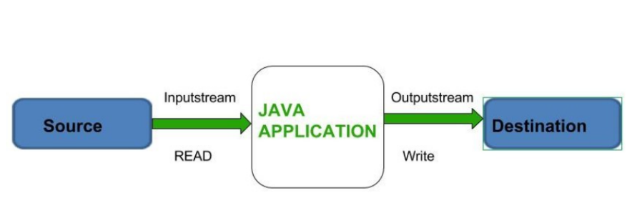
Input and output streams in Java provide a way to read from and write to various data sources and destinations, such as files, network connections, and in-memory buffers. The streams are a fundamental part of Java I/O (Input/Output) and are based on the abstract classes InputStream and OutputStream.

IO Class Hierarchy
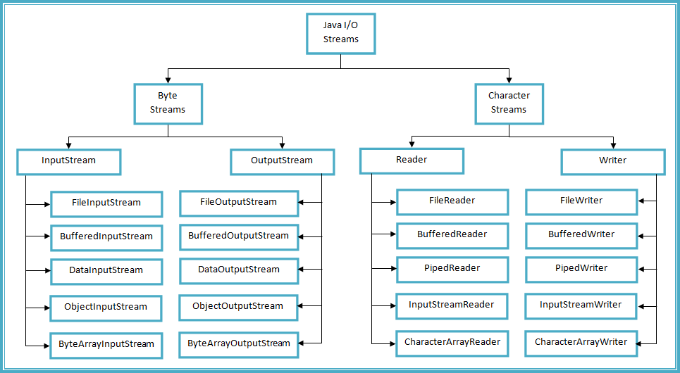

ByteStreams:
Byte streams in Java handle I/O operations at the byte level. They are primarily used for reading and writing binary data, such as images, audio files, or any other non-textual data. Byte streams work with the InputStream and OutputStream classes
Types of ByteStream:
ByteStreams can be divided into two primary classes:
- Input Stream: These streams are used to read data that must be taken as an input from a source array or file or any peripheral device. For eg., FileInputStream, BufferedInputStream, ByteArrayInputStream etc.

- Output Stream: These streams are used to write data as outputs into an array or file or any output peripheral device. For eg., FileOutputStream, BufferedOutputStream, ByteArrayOutputStream etc.

InputStream:
- FileInputStream: Reads data from a file as a sequence of bytes.
- ByteArrayInputStream: Reads data from a byte array.
- BufferedInputStream: Provides buffering capabilities to improve input performance.
- DataInputStream: Reads primitive Java data types from an underlying input stream.
- ObjectInputStream: Reads objects from an underlying input stream, including serialized objects.
OutputStream:
- FileOutputStream: Writes data to a file as a sequence of bytes.
- ByteArrayOutputStream: Writes data to a byte array.
- BufferedOutputStream: Provides buffering capabilities to improve output performance.
- DataOutputStream: Writes primitive Java data types to an underlying output stream.
- ObjectOutputStream: Writes objects to an underlying output stream, including serialized objects.

Example ByteStream:
Lab: Write a Java program to read from file input.txt and write its contents to output.txt.
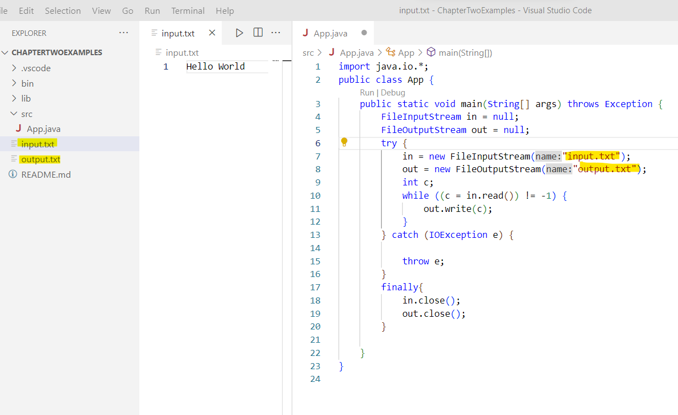
Example BufferInput Stream(Reading File Content)
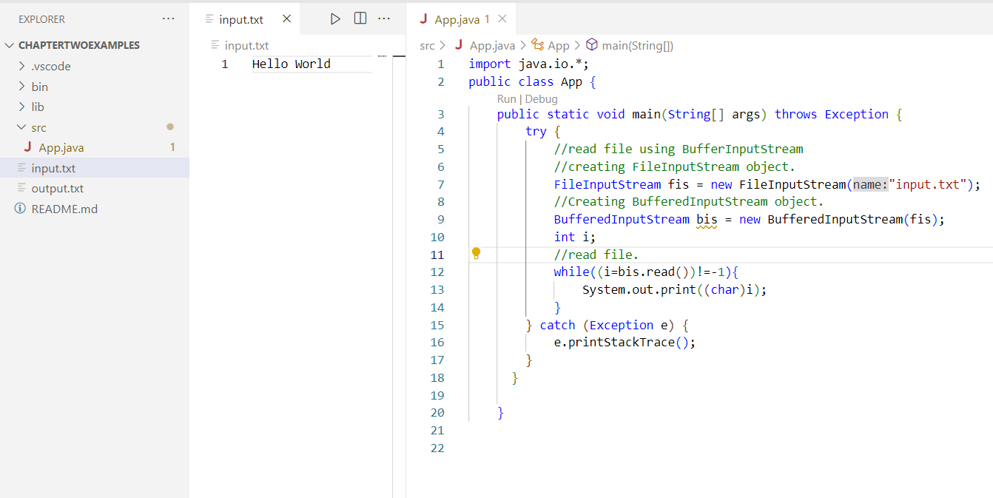

Example BufferOutput Stream(Writing to File)
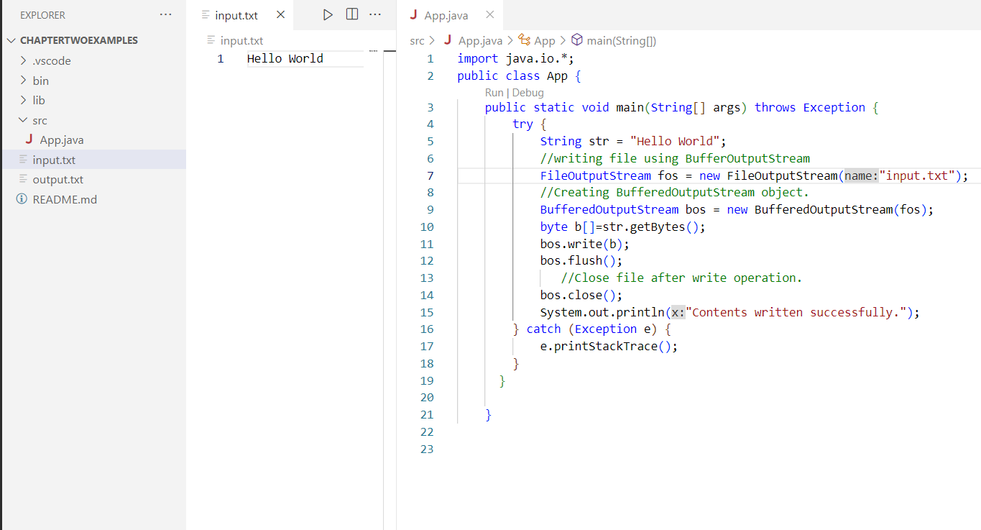

CharacterStreams:
Character streams in Java handle I/O operations at the character level, making them suitable for reading and writing text-based data. They are designed to handle character encoding and decoding automatically, allowing for the reading and writing of characters. Character streams work with the Reader and Writer classes
Types of CharacterStreams:
- Reader: The Reader class is an abstract base class for all character input streams. It defines methods for reading characters from a source and provides a common interface for working with character-based input streams. Some commonly used subclasses of Reader include FileReader, BufferedReader, StringReader, and InputStreamReader.
- Writer: The Writer class is an abstract base class for all character output streams. It defines methods for writing characters to a destination and provides a common interface for working with character-based output streams. Some commonly used subclasses of Writer include FileWriter, BufferedWriter, StringWriter, and OutputStreamWriter.
Character StreamsExample:

Lab: Write a Java program to read from file input.txt and write its contents to output.txt using FileReader and FileWriter(CharacterStreams).
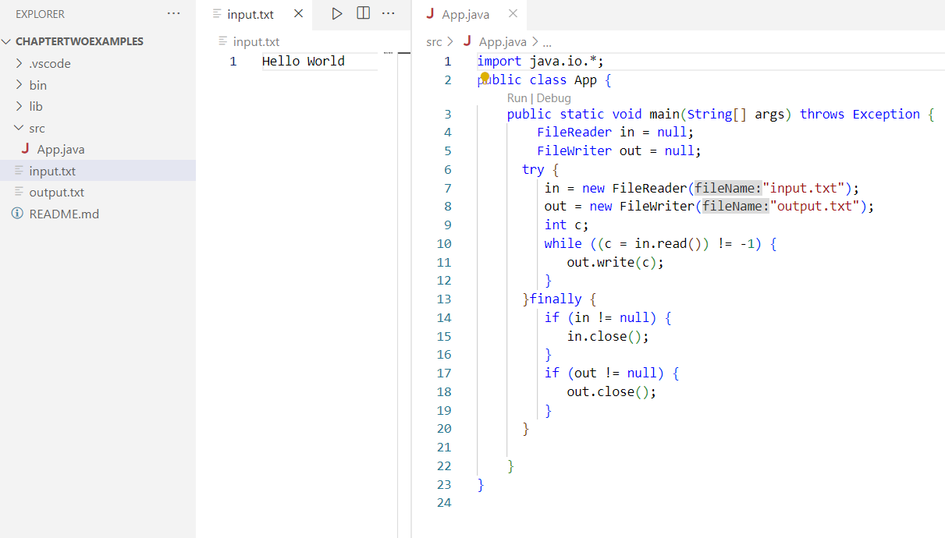

ByteStream Classes:

Stream class | Description
BufferedInputStream | It is used for Buffered Input Stream.
DataInputStream | It contains method for reading java standard datatypes.
FileInputStream | This is used to reads from a file
InputStream | This is an abstract class that describes stream input.
PrintStream | This contains the most used print() and println() method
BufferedOutputStream | This is used for Buffered Output Stream.
DataOutputStream | This contains method for writing java standard data types.
FileOutputStream | This is used to write to a file.
OutputStream | This is an abstract class that describe stream output.

CharacterStream Class

Stream class | Description
BufferedReader | It is used to handle buffered input stream.
FileReader | This is an input stream that reads from file.
InputStreamReader | This input stream is used to translate byte to character.
OutputStreamReader | This output stream is used to translate character to byte.
Reader | This is an abstract class that define character stream input.
PrintWriter | This contains the most used print() and println() method
Writer | This is an abstract class that define character stream output.
BufferedWriter | This is used to handle buffered output stream.
FileWriter | This is used to output stream that writes to file.

File and Directories:
List all file from directories
import java.io.*;
public class App {
public static void main(String[] args) throws Exception {
String directoryPath = "E:\\OOP in Java";
File directory = new File(directoryPath);
File[] files = directory.listFiles();
for (File file : files) {
System.out.println(file.getName());
}
}
}
Create New File:
import java.io.*;
public class App {
public static void main(String[] args) throws Exception {
File file = new File("newfile.txt");
try
{
file.createNewFile();
} catch (IOException e)
{
System.out.println("An error occurred: ");
}
}
}

Copy File:
import java.io.*;
import java.nio.file.*;
public class App {
public static void main(String[] args) throws Exception {
String sourceFilePath = "E://OOP in Java//Threads.docx";
String destinationFilePath = "E://OOP in Java//Sample Questions//Threads.docx";
Path sourcePath = Paths.get(sourceFilePath);
Path destinationPath = Paths.get(destinationFilePath);
try {
Files.copy(sourcePath, destinationPath);
System.out.println("File copied successfully!");
} catch (IOException e) {
System.out.println("An error occurred: " + e.getMessage());
}
}
}
Delete File:
import java.io.*;
import java.nio.file.*;
public class App {
public static void main(String[] args) throws Exception {
String filePath = "E://OOP in Java//Threads.docx";
Path path = Paths.get(filePath);
try {
Files.delete(path);
System.out.println("File deleted successfully!");
} catch (IOException e) {
System.out.println("An error occurred: " + e.getMessage());
}
}
}
Object Serialization: (reading and writing object)
Object serialization is the process of converting an object into a byte stream, which can be saved to a file, sent over a network, or stored in a database. It is mainly used in Hibernate, RMI (Remote Method Invocation) technologies.
The reverse operation of serialization is called deserialization where byte-stream is converted into an object. The serialization and deserialization process is platform-independent, it means you can serialize an object on one platform and deserialize it on a different platform.
For serializing the object, we call the writeObject() method of ObjectOutputStream class, and for deserialization we call the readObject() method of ObjectInputStream class.
Syntax for the writeObject() method:
public final void writeObject(Object o) throws IO Exception
Syntax for the readObject() method:
public final Object readObject() throws IOException, ClassNotFoundException

Lab: Write a java program to demonstrate Object serialization and deserialization.
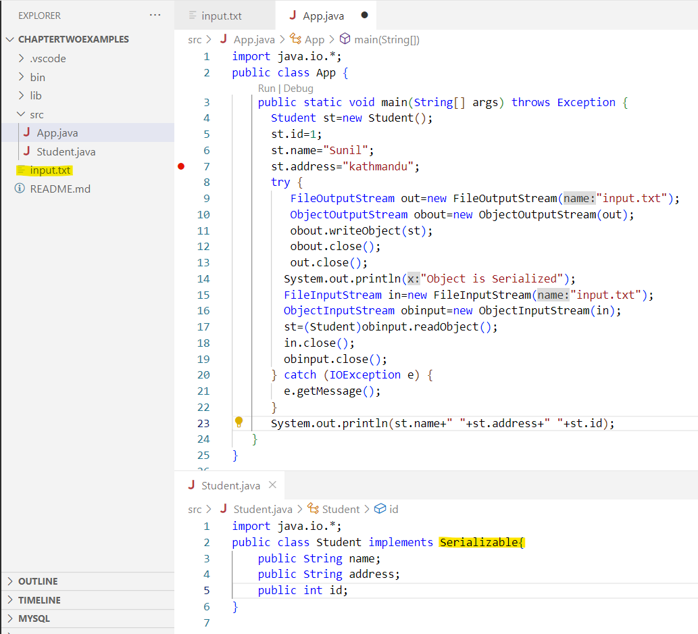

RandomAccessFile

The RandomAccessFile class is used to perform random access to a file. Unlike other file handling classes like FileInputStream or FileOutputStream, which provide sequential access to a file, RandomAccessFile allows you to read from or write to any position within the file.

To work with a file using RandomAccessFile, you first need to create an instance of the class. You can do this by providing the file path and the mode (read-only, write-only, or both) as parameters to the constructor.

There are two modes: "r" for reading and "rw" for reading and writing.
Reading from a RandomAccessFile:
RandomAccessFile raf = new RandomAccessFile("example.txt", "r");
byte[] buffer = new byte[1024];
int bytesRead = raf.read(buffer);

Writing To a RandomAccessFile:
RandomAccessFile raf = new RandomAccessFile("example.txt", "rw");
byte[] data = "Hello, World!".getBytes();
raf.write(data);

Moving Pointer:
raf.seek(50);

Closing RandomAccessFile:
raf.close();

Lab: Write a java program to read, read write using RandomAccessFile
Example:
import java.io.*;
public class App {
public static void main(String[] args)
{
String FILEPATH ="input.txt";
try {
System.out.println(new String(readFromFile(FILEPATH, 0, 18)));
writeToFile(FILEPATH, "Stay positive. Better days are on their way.", 31);
System.out.println(new String(readFromFile(FILEPATH, 0,100)));
} catch (IOException e) {
e.printStackTrace();
}
}

private static byte[] readFromFile(String filePath, int position, int size)
throws IOException {
RandomAccessFile file = new RandomAccessFile(filePath, "r");
file.seek(position);
byte[] bytes = new byte[size];
file.read(bytes);
file.close();
return bytes;
}
private static void writeToFile(String filePath, String data, int position)
throws IOException {
RandomAccessFile file = new RandomAccessFile(filePath, "rw");
file.seek(position);
file.write(data.getBytes());
file.close();
}
}

1.Write a simple java program to read from and write to files
2.Discuss any 5 exception classes in java.
3. Explain the importance of exception handling with suitable example.
4. Write the simple java program that reads data from one file and writes data to another file.
5.Why do we need to handle the exception? Distinguish error and exception, Write a program to demonstrate your own exception class
6. What is exception handling? Discuss the use of each keyword (try, catch, throw, throws and finally) with suitable Java program.
7. Write a program to read an input string from the user and write the vowels of that string in VOWEL.TXT and consonants in CONSOLNANT.TXT
Code:

import java.io.FileWriter;
import java.io.IOException;
import java.util.Scanner;

public class App extends Thread {
public static void main(String[] args) {
Scanner sc = new Scanner(System.in);
String s = sc.next();
String vowel = "";
String consonant = "";
for (int i = 0; i < s.length(); i++) {
if (s.charAt(i) == 'a' || s.charAt(i) == 'A' || s.charAt(i) == 'e' || s.charAt(i) == 'E'
|| s.charAt(i) == 'i' || s.charAt(i) == 'I' || s.charAt(i) == 'o' || s.charAt(i) == 'O'
|| s.charAt(i) == 'u' || s.charAt(i) == 'U') {
vowel += s.charAt(i);

} else {
consonant += s.charAt(i);
}
}
try {
FileWriter vWriter = new FileWriter("E:VOWEL.txt");
// Writes this content into the specified file
vWriter.write(vowel);

// Closing is necessary to retrieve the resources allocated
vWriter.close();

FileWriter cWriter = new FileWriter("E:CONSONANT.txt");
// Writes this content into the specified file
cWriter.write(consonant);

// Closing is necessary to retrieve the resources allocated
cWriter.close();

} catch (IOException e) {
System.out.println("An error occurred.");
e.printStackTrace();

}

}
}

8. What is the task of manifest file? Write the procedure to create it
In the Java programming language, a manifest file is a text file that contains metadata related to files contained in a programmer's JAR archive. This metadata can range from information relating to package information to attributes of security properties
Code:
import java.io.File;

import java.io.IOException;

public class App extends Thread {
public static void main(String[] args) {
try {
// Creating an object of a file
File myObj = new File("E:Test.jar");
if (myObj.createNewFile())
{
System.out.println("File created: " + myObj.getName());
} else
{
System.out.println("File already exists.");
}
} catch (IOException e)
{
System.out.println("An error occurred.");
e.printStackTrace();
}

}
}

